Franklin Academy – ELA
Grade 7 - Mood Project
“Another Place, Another Time”
Due: Monday 21, 2018
- Re-read the pages from the text that have been assigned to you.
- Decide on at least 2 adjectives that describe the overall mood of each page. Include those adjectives on the page of text.
- Circle the words and phrases that helped you determine the mood. (Remember mood is the atmosphere of a piece of writing; it’s the emotions a selection arouses in a reader. Think about how that page of the story makes you feel)
- Then create a colorful image on the page of text. The image should reflect the moods you listed on the page. You must use colored pencils or crayons (no markers). The idea is that the author’s words still show through. Example image below.
- Provide a 2 paragraph explanation of your images and their connections to the overall moods you identified.
Example:
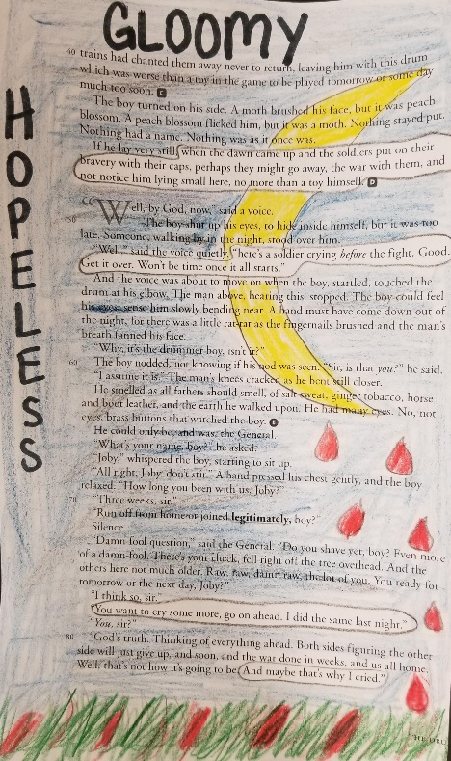
Positive Mood Word Possibilities: amused, loving, happy, peaceful, playful, relieved, satisfied, passionate, hopeful, confident, optimistic, surprised, thankful, joyous, content, pleased, grateful, harmonious, welcoming, dreamy, humorous, etc.

Negative Mood Word Possibilities: lonely, grumpy, gloomy, annoyed, disappointed, rejected, scared, stressed, confused, overwhelmed, dreary, heartbroken, serious, somber, worried, uncomfortable, anxious, aggravated, hostile, etc.

